Change of Plans International Day: lkaria, Greece

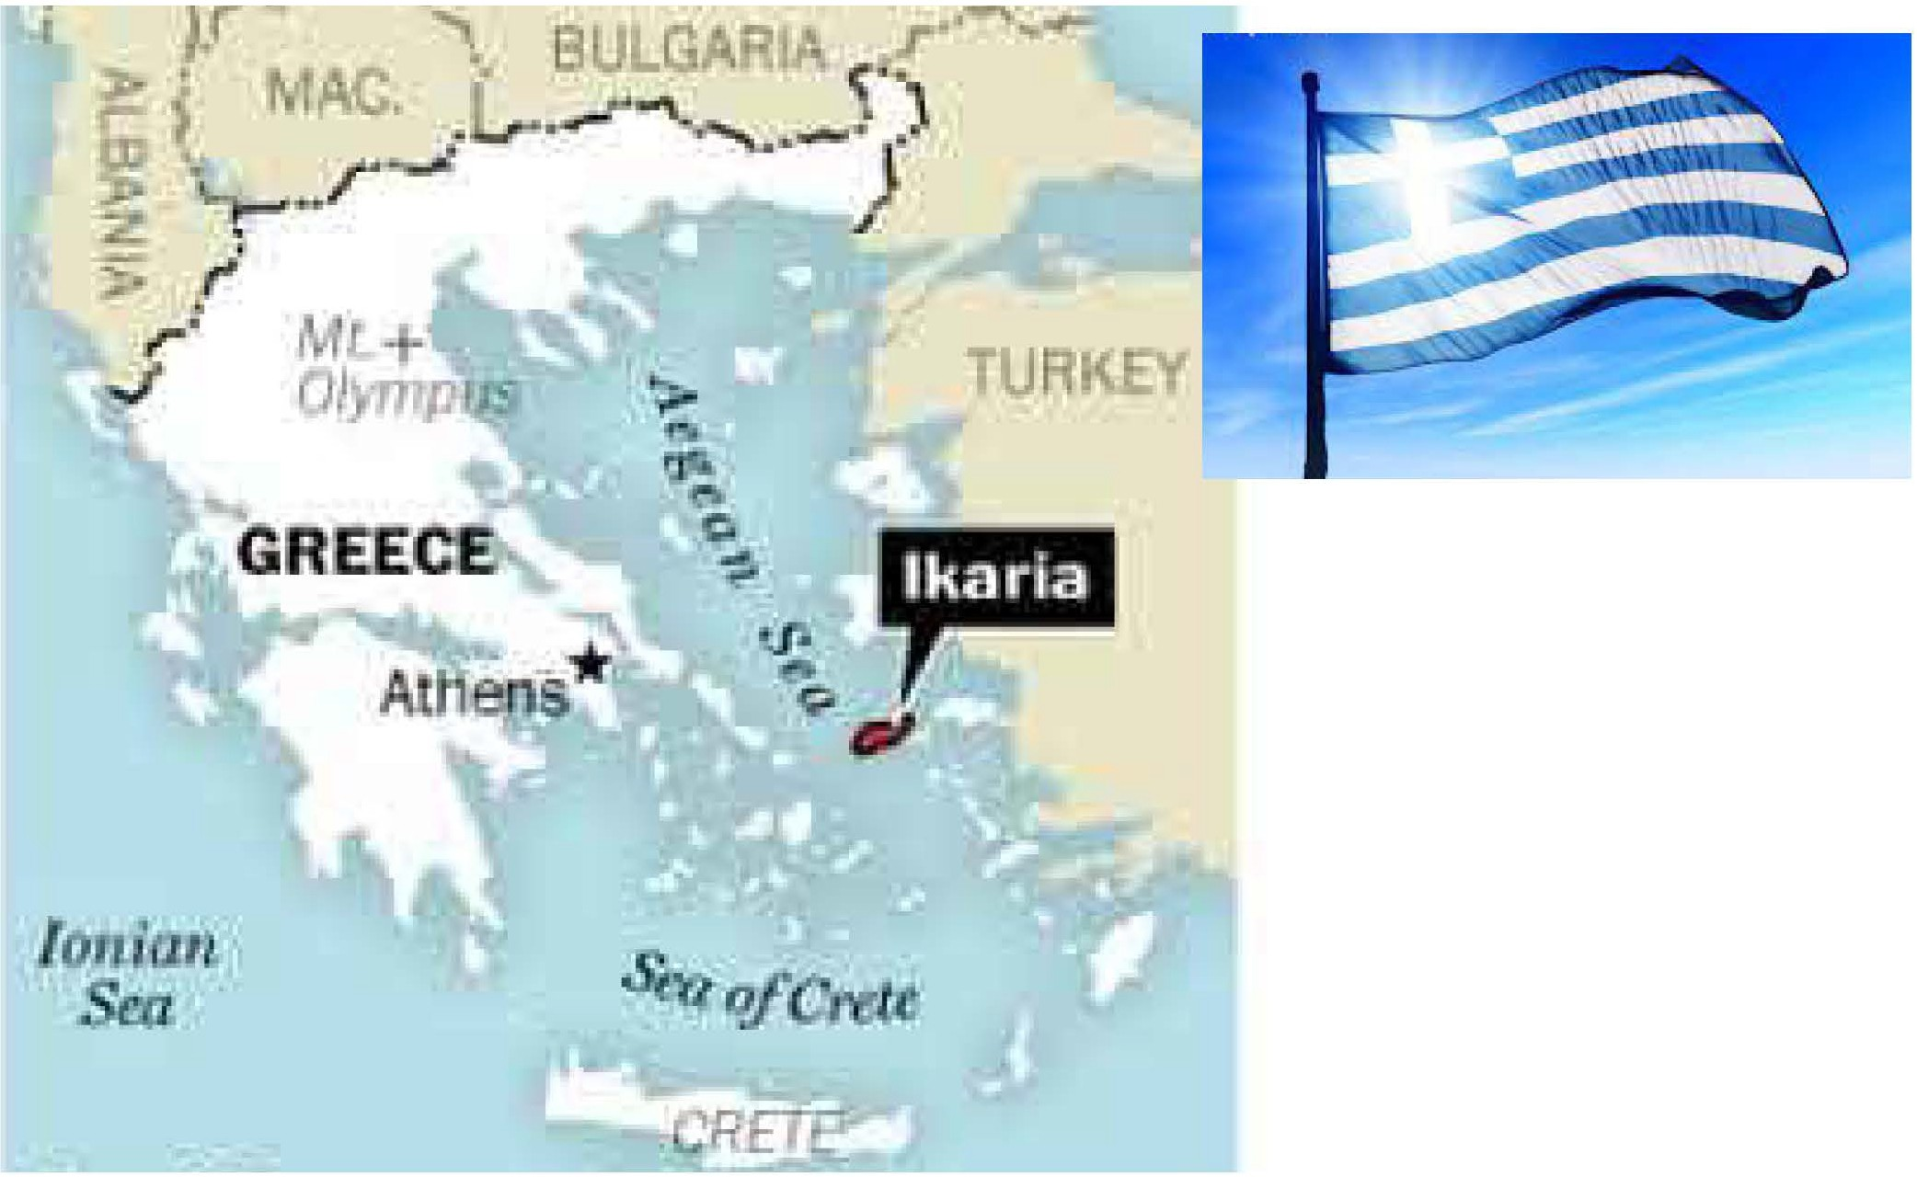

Come join us and learn about the geography, culture, and dietary habits of centenarians who live in lkaria, Greece. We will cover the 7 characteristics research has found in those who live to be centenarians. The basics of Sourdough bread will be taught before and after we sample some food from lkaria. Bring your own sack lunch to stay for further tips on baking sour dough.

# Thursday, Feb 29,2024

**at the Bullitt Co. Extension office at 10am**

Bullitt County Extension Office 384 Halls Lane

Shepherdsville, KY 40165

# Reserve your spot at 502-543-2257

**Cooperative Extension Service**

**MARTIN-GATTON COLLEGE OF AGRICULTURE, FOOD AND ENVIRONMENT**

Educational programs of Kentucky Cooperative Extension serve all people regardless of economic or social status

Agriculture and Natural Resources Family and Consumer Sciences

4-H Youth Development

Community and Economic Development

and will not discriminate on the basis of race, color, ethnic origin, national origin, creed, religion, political belief, sex.

sexual orientation, gender identity, gender expression, pregnancy, marital status, genetic information, age, veteran status, physical or mental disability or reprisal or retaliation for prior civil rights activity. Reasonable accommodation of disability may be available with prior notice. Program information may be made available in languages other than English.

•

University of Kentucky, Kentucky State University, U.S. Department of Agriculture, and Kentucky Counties, Cooperating.

Lexington, KY 40506

6.

Disabilities

..,. accommodated

with prior notification.